**PA MW AND AMP ETL SERVER PATCHING INSTRUCTIONS**

**Pre-patch Validation Steps**:

1. Access Requirements:

* None as we assume App admin is running validation and has all requisite ETL server access.
* PA Production ETL server url is UVACPMMETL01MXD.MAXCORP.MAXIMUS; port 22
* AMP ADC ETL server is uvacpmmetl01amp.maxcorp.maximus; port 22

1. Create a **backup** of cron jobs on PA ETL server and delete the crontab from the server, so no crons run during patching.

PA cron job names and their urls are in SVN location **svn://svn-staging.maximus.com/dev1d/maxdat/ContactCenter/trunk/kettle/MAXDAT/implementation/CiscoEnterprise/documentation/PA Crons**

1. Confirm no jobs are running
   1. ps –aux | less

Note: If any of the cron jobs are running, please wait for them to complete before starting the patching.

**Post-patch validation Steps:**

**PA MW PATCHING**

1. Verify that log files are being created after patching in **/u01/maximus/maxdat-prd/PA/logs/** during ETL interval of 45 minutes.

The first log file should be created at the start of the hour and the last one at the 45th minute of the hour. For example, 13:00-13:45 is a time window for all logs to be created for 13th hour.

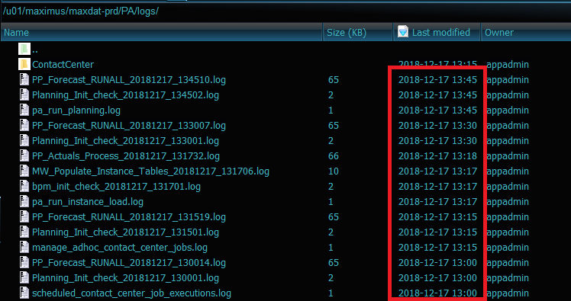

1. Verify Run_Initialization log was created for the day. It gets created at 03:03 every day and has size 265 KB. If the size is significantly less, there was an error that needs to be investigated.

We can also check for errors using Linux command:

grep -E [\w]*'ORA/-|java'[\w]* "<LATEST LOG FILE NAME>.log"



1. Reach out to DBA to verify PA MW. DBA has instructions on how to do this.

**AMP DATA LOAD**

1. If the DBA reaches out to check AMP Data Load logs, check AMP ETL server (uvacpmmetl01amp.maxcorp.maximus; port 22) location **/u01/maximus/maxdat-prd/mots/Automated_Data_Capture/Error/** for any issues. The failure log will be created in this location.

The successful log will be created here: **/u01/maximus/maxdat-prd/mots/files/template/Completed/**

If there is an error log, please investigate and let DBA know if database is down. If error cannot be diagnosed, please contact available MAXDAT developer.

**AMP WEB PRD**

1. To verify the PRD AMP web server, please login at

<https://maxamp.maximus.com/login> and select View Previously Submitted Actuals and verify if data loaded until last Saturday.